**Wireless Mobile Phone (DTMF) controlled irrigation motor/AC appliances**

**CHAPTER 1**

**INTRODUCTION**

**ABSTRACT**

The aim of this project is to provide an efficient solution for control of irrigation motor/AC Appliances with DTMF technologies. Now a day’s technology is running with time, it completely occupied the life style of human beings. Even though there is such an importance for technology in our routine life there are even people whose life styles are very far to this well known term technology. So it is our responsibility to design few reliable systems which can be even efficiently used by them. This basic idea gave birth to the project DTMF controlled irrigation motor. Here the process is done through the micro controller based technology.

**EXISTING SYSTEM**

The existing system has over irrigation problems and under irrigation problems because it has no controlling systems .And land is more and manpower and labour requirement is also needs in high amount.

**PROPOSED SYSTEM**

Automatic irrigation systems are convenient,especially for those who travel. If installed and programmed properly , automatic irrigation systems can even save you money and help in water conservation. Agriculture is a source of livelihood of majority Indians and has great impact on the economy of the country. In dry areas or in case of inadequate rainfall, irrigation becomes difficult. So, it needs to be automated for proper yield and handled remotely for farmer safety. In this paper we suggest a Wireless sensor network and Embedded based technique of DTMF (Dual Tone Multiple Frequency) signaling to control water flow for sectored, sprinkler or drip section irrigation. This system will be very economical in terms of the hardware cost, power consumption and call charges.

**BLOCK DIAGRAM**

**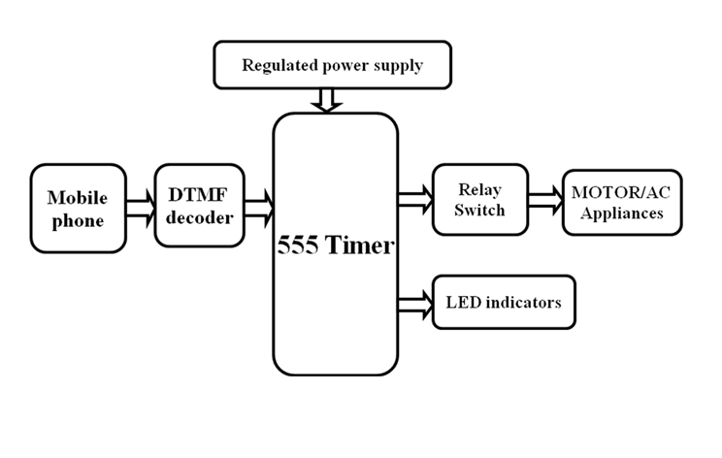**

**MAJOR BLOCKS**

* 555 Timer
* Regulated power supply
* DTMF Decoder
* Realy
* Motor
* Mobile phone

**SOFTWARE REQUIRED**

* SOFTWARE REQUIRED
* Embedded c
* Kiel IDE

**CHAPTER 2**

**2.1 EMBEDDED SYSTEM**

An embedded system can be defined as a computing device that does a specific focused job. Appliances such as the air-conditioner, VCD player, DVD player, printer, fax machine, mobile phone etc. are examples of embedded systems. Each of these appliances will have a processor and special hardware to meet the specific requirement of the application along with the embedded software that is executed by the processor for meeting that specific requirement. The embedded software is also called “firm ware”. The desktop/laptop computer is a general purpose computer. You can use it for a variety of applications such as playing games, *word* processing, accounting, software development and so on. In contrast, the software in the embedded systems is always fixed listed below:

· Embedded systems do a very specific task, they cannot be programmed to do different things. . Embedded systems have very limited resources, particularly the memory. Generally, they do not have secondary storage devices such as the CDROM or the floppy disk. Embedded systems have to work against some deadlines. A specific job has to be completed within a specific time. In some embedded systems, called real-time systems, the deadlines are stringent. Missing a deadline may cause a catastrophe-loss of life or damage to property. Embedded systems are constrained for power. As many embedded systems operate through a battery, the power consumption has to be very low.

· Some embedded systems have to operate in extreme environmental conditions such as very high temperatures and humidity.

**Application Areas**

Nearly 99 per cent of the processors manufactured end up in embedded systems. The embedded system market is one of the highest growth areas as these systems are used in very market segment- consumer electronics, office automation, industrial automation, biomedical engineering, wireless communication, data communication, telecommunications, transportation, military and so on.

**Consumer appliances**:

At home we use a number of embedded systems which include digital camera, digital diary, DVD player, electronic toys, microwave oven, remote controls for TV and air-conditioner, VCO player, video game consoles, video recorders etc. Today’s high-tech car has about 20 embedded systems for transmission control, engine spark control, air-conditioning, navigation etc. Even wristwatches are now becoming embedded systems. The palmtops are powerful embedded systems using which we can carry out many general-purpose tasks such as playing games and word processing.

**Office Automation:**

The office automation products using embedded systems are copying machine, fax machine, key telephone, modem, printer, scanner etc.

**Industrial Automation**:

Today a lot of industries use embedded systems for process control. These include pharmaceutical, cement, sugar, oil exploration, nuclear energy, electricity generation and transmission. The embedded systems for industrial use are designed to carry out specific tasks such as monitoring the temperature, pressure, humidity, voltage, current etc., and then take appropriate action based on the monitored levels to control other devices or to send information to a centralized monitoring station. In hazardous industrial environment, where human presence has to be avoided, robots are used, which are programmed to do specific jobs. The robots are now becoming very powerful and carry out many interesting and complicated tasks such as hardware assembly.

**Medical Electronics**:

Almost every medical equipment in the hospital is an embedded system. These equipments include diagnostic aids such as ECG, EEG, blood pressure measuring devices, X-ray scanners; equipment used in blood analysis, radiation, colonoscopy, endoscopy etc. Developments in medical electronics have paved way for more accurate diagnosis of diseases.

**Computer Networking**:

Computer networking products such as bridges, routers, Integrated Services Digital Networks (ISDN), Asynchronous Transfer Mode (ATM), X.25 and frame relay switches are embedded systems which implement the necessary data communication protocols. For example, a router interconnects two networks. The two networks may be running different protocol stacks. The router’s function is to obtain the data packets from incoming pores, analyze the packets and send them towards the destination after doing necessary protocol conversion. Most networking equipments, other than the end systems (desktop computers) we use to access the networks, are embedded systems.

**Telecommunications**:

In the field of telecommunications, the embedded systems can be categorized as subscriber terminals and network equipment. The subscriber terminals such as key telephones, ISDN phones, terminal adapters, web cameras are embedded systems. The network equipment includes multiplexers, multiple access systems, Packet Assemblers Dissemblers (PADs), sate11ite modems etc. IP phone, IP gateway, IP gatekeeper etc. are the latest embedded systems that provide very low-cost voice communication over the Internet.

**Wireless Technologies**:

Advances in mobile communications are paving way for many interesting applications using embedded systems. The mobile phone is one of the marvels of the last decade of the 20’h century. It is a very powerful embedded system that provides voice communication while we are on the move. The Personal Digital Assistants and the palmtops can now be used to access multimedia service over the Internet. Mobile communication infrastructure such as base station controllers, mobile switching centers are also powerful embedded systems.

**Insemination:**

Testing and measurement are the fundamental requirements in all scientific and engineering activities. The measuring equipment we use in laboratories to measure parameters such as weight, temperature, pressure, humidity, voltage, current etc. are all embedded systems. Test equipment such as oscilloscope, spectrum analyzer, logic analyzer, protocol analyzer, radio communication test set etc. are embedded systems built around powerful processors. Thank to miniaturization, the test and measuring equipment are now becoming portable facilitating easy testing and measurement in the field by field-personnel.

**Security:**

Security of persons and information has always been a major issue. We need to protect our homes and offices; and also the information we transmit and store. Developing embedded systems for security applications is one of the most lucrative businesses nowadays. Security devices at homes, offices, airports etc. for authentication and verification are embedded systems. Encryption devices are nearly 99 per cent of the processors that are manufactured end up in~ embedded systems. Embedded systems find applications in every industrial segment- consumer electronics, transportation, avionics, biomedical engineering, manufacturing, process control and industrial automation, data communication, telecommunication, defense, security etc. Used to encrypt the data/voice being transmitted on communication links such as telephone lines. Biometric systems using fingerprint and face recognition are now being extensively used for user authentication in banking applications as well as for access control in high security buildings.

**Finance:**

Financial dealing through cash and cheques are now slowly paving way for transactions using smart cards and ATM (Automatic Teller Machine, also expanded as Any Time Money) machines. Smart card, of the size of a credit card, has a small micro-controller and memory; and it interacts with the smart card reader! ATM machine and acts as an electronic wallet. Smart card technology has the capability of ushering in a cashless society. Well, the list goes on. It is no exaggeration to say that eyes wherever you go, you can see, or at least feel, the work of an embedded system.

**Overview of Embedded System Architecture**

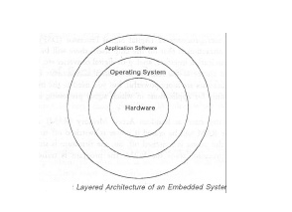Every embedded system consists of custom-built hardware built around a Central Processing Unit (CPU). This hardware also contains memory chips onto which the software is loaded. The software residing on the memory chip is also called the ‘firmware’. The embedded system architecture can be represented as a layered architecture as shown in Fig. The operating system runs above the hardware, and the application software runs above the operating system. The same architecture is applicable to any computer including a desktop computer. However, there are significant differences. It is not compulsory to have an operating system in every embedded system. For small appliances such as remote control units, air conditioners, toys etc., there is no need *for* an operating system and you can write only the software specific to that application. For applications involving complex processing, it is advisable to have an operating system. In such a case, you need to integrate the application software with the operating system and then transfer the entire software on to the memory chip. Once the software is transferred to the memory chip, the software will continue to run *for* a long time you don’t need to reload new software.

Now, let us see the details of the various building blocks of the hardware of an embedded system. As shown in Fig. the building blocks are;

· Central Processing Unit (CPU)

· Memory (Read-only Memory and Random Access Memory)

· Input Devices

· Output devices

· Communication interfaces

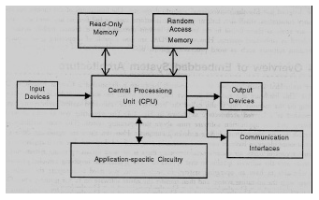· Application-specific circuitry

**Central Processing Unit (CPU):**

The Central Processing Unit (processor, in short) can be any of the following: microcontroller, microprocessor or Digital Signal Processor (DSP). A micro-controller is a low-cost processor. Its main attraction is that on the chip itself, there will be many other components such as memory, serial communication interface, analog-to digital converter etc. So, for small applications, a micro-controller is the best choice as the number of external components required will be very less. On the other hand, microprocessors are more powerful, but you need to use many external components with them. D5P is used mainly for applications in which signal processing is involved such as audio and video processing.

**Memory:**

The memory is categorized as Random Access 11emory (RAM) and Read Only Memory (ROM). The contents of the RAM will be erased if power is switched off to the chip, whereas ROM retains the contents even if the power is switched off. So, the firmware is stored in the ROM. When power is switched on, the processor reads the ROM; the program is program is executed.

**Input Devices**:

Unlike the desktops, the input devices to an embedded system have very limited capability. There will be no keyboard or a mouse, and hence interacting with the embedded system is no easy task. Many embedded systems will have a small keypad-you press one key to give a specific command. A keypad may be used to input only the digits. Many embedded systems used in process control do not have any input device *for* user interaction; they take inputs *from* sensors or transducers 1’fnd produce electrical signals that are in turn fed to other systems.

**Output Devices**:

The output devices of the embedded systems also have very limited capability. Some embedded systems will have a *few* Light Emitting Diodes (LEDs) *to* indicate the health status of the system modules, or *for* visual indication of alarms. A small Liquid Crystal Display (LCD) may also be used to display *some* important parameters.

**Communication Interfaces**:

The embedded systems may need to, interact with other embedded systems at they may have to transmit data to a desktop. To facilitate this, the embedded systems are provided with one or a *few* communication interfaces such as RS232, RS422, RS485, Universal Serial Bus (USB), IEEE 1394, Ethernet etc.

**Application-Specific Circuitry**:

Sensors, transducers, special processing and control circuitry may be required fat an embedded system, depending on its application. This circuitry interacts with the processor to carry out the necessary work. The entire hardware has to be given power supply either through the 230 volts main supply or through a battery. The hardware has to design in such a way that the power consumption is minimized.

**CHAPTER 3**

**HARDWARE SPECIFICATIONS**

**POWER SUPPLY**

The power supply section is the section which provide +5V for the components to work. IC LM7805 is used for providing a constant power of +5V.

The ac voltage, typically 220V, is connected to a transformer, which steps down that ac voltage down to the level of the desired dc output. A diode rectifier then provides a full-wave rectified voltage that is initially filtered by a simple capacitor filter to produce a dc voltage. This resulting dc voltage usually has some ripple or ac voltage variation.

A regulator circuit removes the ripples and also retains the same dc value even if the input dc voltage varies, or the load connected to the output dc voltage changes. This voltage regulation is usually obtained using one of the popular voltage regulator IC units.

****

Fig: Block Diagram of Power Supply

**3.1.1 TRANSFORMER**

Transformers convert AC electricity from one voltage to another with little loss of power. Transformers work only with AC and this is one of the reasons why mains electricity is AC.

Step-up transformers increase voltage, step-down transformers reduce voltage. Most power supplies use a step-down transformer to reduce the dangerously high mains voltage (230V in India) to a safer low voltage.

The input coil is called the primary and the output coil is called the secondary. There is no electrical connection between the two coils; instead they are linked by an alternating magnetic field created in the soft-iron core of the transformer. Transformers waste very little power so the power out is (almost) equal to the power in. Note that as voltage is stepped down current is stepped up.

The transformer will step down the power supply voltage (0-230V) to (0- 6V) level. Then the secondary of the potential transformer will be connected to the bridge rectifier, which is constructed with the help of PN junction diodes. The advantages of using bridge rectifier are it will give peak voltage output as DC.

**3.1.2 RECTIFIER**

There are several ways of connecting diodes to make a rectifier to convert AC to DC. The bridge rectifier is the most important and it produces full-wave varying DC. A full-wave rectifier can also be made from just two diodes if a centre-tap transformer is used, but this method is rarely used now that diodes are cheaper. A single diode can be used as a rectifier but it only uses the positive (+) parts of the AC wave to produce half-wave varying DC

**3.1.3 BRIDGE RECTIFIER**

When four diodes are connected as shown in figure, the circuit is called as bridge rectifier. The input to the circuit is applied to the diagonally opposite corners of the network, and the output is taken from the remaining two corners. Let us assume that the transformer is working properly and there is a positive potential, at point A and a negative potential at point B. the positive potential at point A will forward bias D3 and reverse bias D4.



Fig: Bridge Rectifier

The negative potential at point B will forward bias D1 and reverse D2. At this time D3 and D1 are forward biased and will allow current flow to pass through them; D4 and D2 are reverse biased and will block current flow.

One advantage of a bridge rectifier over a conventional full-wave rectifier is that with a given transformer the bridge rectifier produces a voltage output that is nearly twice that of the conventional full-wave circuit.

i. The main advantage of this bridge circuit is that it does not require a special centre tapped transformer, thereby reducing its size and cost.

ii. The single secondary winding is connected to one side of the diode bridge network and the load to the other side as shown below.

iii. The result is still a pulsating direct current but with double the frequency.

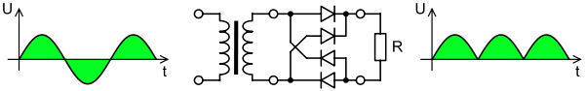

Fig: Output Waveform of DC

**3.1.4 SMOOTHING**

Smoothing is performed by a large value electrolytic capacitor connected across the DC supply to act as a reservoir, supplying current to the output when the varying DC voltage from the rectifier is falling. The capacitor charges quickly near the peak of the varying DC, and then discharges as it supplies current to the output.

**3.1.5 VOLTAGE REGULATORS**

Voltage regulators comprise a class of widely used ICs. Regulator IC units contain the circuitry for reference source, comparator amplifier, control device, and overload protection all in a single IC. IC units provide regulation of either a fixed positive voltage, a fixed negative voltage, or an adjustably set voltage. The regulators can be selected for operation with load currents from hundreds of milli amperes to tens of amperes, corresponding to power ratings from milli watts to tens of watts.

A fixed three-terminal voltage regulator has an unregulated dc input voltage, Vi, applied to one input terminal, a regulated dc output voltage, Vo, from a second terminal, with the third terminal connected to ground.

The series 78 regulators provide fixed positive regulated voltages from 5 to 24 volts. Similarly, the series 79 regulators provide fixed negative regulated voltages from 5 to 24 volts. Voltage regulator ICs are available with fixed (typically 5, 12 and 15V) or variable output voltages. They are also rated by the maximum current they can pass. Negative voltage regulators are available, mainly for use in dual supplies. Most regulators include some automatic protection from excessive current ('overload protection') and overheating ('thermal protection').

Many of the fixed voltage regulator ICs has 3 leads and look like power transistors, such as the 7805 +5V 1Amp regulator. They include a hole for attaching a heat sink if necessary.

****

Fig: Regulator

****

Fig: Circuit Diagram of Power Supply

**LIGHT EMITTING DIODE(LED)**

LED is abbreviation of Light Emitting Diode. It’s nothing, but just a combination of semiconductors which emits light when current pass through it . Over the years, semiconductor technology has advanced to bigger heights, Light Emitting Devices have also been a part of this revolution and as a result, Now we have LED’s which give better illumination with low power consumption.

**Types of LED**– There are many types of LEDs available in the market.. As you can see on above pic there is different LEDs according to our requirement and there has been many other are too available depending upon different parameters . And LEDs are choose according to parameters like space required by it, size, intensity, colors, etc. Typical LEDs are in size of 3mm, 5mm and 8mm. Nowadays HPLEDs(high power LEDs) are running in market which emits higher luminous intensity. High power LED’s has very high heat dissipation so LED’s need to mounted along with a cooling system known as heat sink.

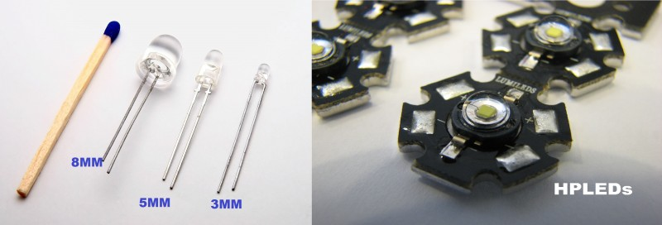

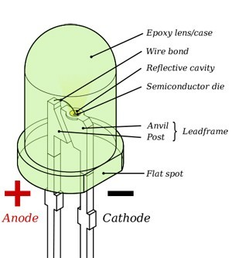

**Operating parameters & circuit symbol**– Above figures show basic elements inside the LED and circuit symbol which helps in interfacing LED with 8051. Typical current ratings ranges from around 1 mA to above 20 mA and voltage is at about colors.

* 1.9 to 2.1 V for red, orange and yellow,
* 3.0 to 3.4 V for green and blue,
* 2.9 to 4.2 V for violet, pink, purple and white.
* 5 V and 12 V LEDs are incorporate a suitable [series](http://en.wikipedia.org/wiki/Series_and_parallel_circuits#Resistors) [resistor](http://en.wikipedia.org/wiki/Resistor) for direct connection to a 5 V or 12 V supply.

**Applications-**LED is everywhere because it’s an indicating component used in many areas. Just look around, if u can’t find even single LED, you are not on earth.

**555 TIMER IC**

**3.3.1 INTRODUCTION:**

The 555 timer IC was first introduced around 1971 by the Signetics Corporation as the SE555/NE555 and was called "The IC Time Machine" and was also the very first and only commercial timer ic available. It provided circuit designers and hobby tinkerers with a relatively cheap, stable, and user-friendly integrated circuit for both monostable and astable applications. Since this device was first made commercially available, a myrad of novel and unique circuits have been developed and presented in several trade, professional, and hobby publications. The past ten years some manufacturers stopped making these timers because of competition or other reasons. Yet other companies, like [NTE](http://www.nteinc.com) (a subdivision of Philips) picked up where some left off.

This primer is about this fantastic timer which is after 30 years still very popular and used in many schematics. Although these days the CMOS version of this IC, like the [Motorola](http://www.motorola.com) MC1455, is mostly used, the regular type is still available, however there have been many improvements and variations in the circuitry. But all types are pin-for-pin plug compatible.

This timer uses a maze of transistors, diodes and resistors and for this complex reason I will use a more simplified (but accurate) block diagram to explain the internal organizations of the 555.

The 555 timer integrated circuit (IC) has become a mainstay in electronics design. A 555 timer will produce a pulse when a trigger signal is applied to it. The pulse length is determined by charging then discharging a capacitor connected to a 555 timer. A 555 timer can be used to debounce switches, modulate signals, create accurate clock signals, create pulse width modulated (PWM) signals, etc. A 555 timer can be obtained from various manufacturers including Fairchild Semiconductor and National Semiconductor.

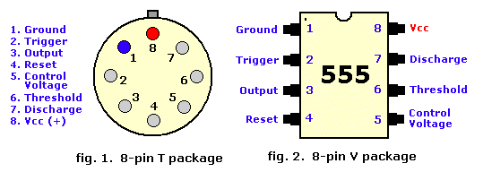

    A 555 timer is a semiconductor device that controls various modes of on/off states in electrical systems. The 555 timer is one of the most widely used types of integrated circuits. The 555 in figures above, come in two packages, either the round metal-can called the 'T' package or the more familiar 8-pin DIP 'V' package. About 20-years ago the metal-can type was pretty much the standard (SE/NE types). The 556 timer is a dual 555 version and comes in a 14-pin DIP package, the 558 is a quad version with four 555's also in a 14 pin DIP case.

: 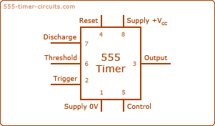

**3.3.2 PIN DESCRIPTION:**

**Pin 1 (Ground):**

Connects to the 0v power supply Ground connection for chip

**Pin 2 (Trigger):**

Detects 1/3 of rail voltage to make output HIGH Pin 2 has control over pin 6. If pin 2 is LOW, and pin 6 LOW,  output goes and stays HIGH. If pin 6 HIGH, and pin 2 goes LOW, output goes LOW while pin 2 LOW. This pin has a very high impedance (about 10M) and will trigger with about 1uA. 555 timer triggers when this pin transitions from voltage at Vcc to 33% v voltage at Vcc. Output pin goes high when triggered

**Pin 3 (Output):**

(Pins 3 and 7 are "in phase.") Goes HIGH (about 2v less than rail) and LOW (about 0.5v less than 0v) and will deliver up to 200mA.

**Pin 4 (Reset):**

Internally connected HIGH via 100k Must be taken below 0.8v to reset the chip Resets 555 timer when low

**Pin 5 (Control):**

Used to change Threshold and Trigger set point voltages and is rarely used A voltage applied to this pin will vary the timing of the RC network (quite considerably).

**Pin 6 (Threshold):**

Used to detect when the capacitor has charged The Output pin goes low w when capacitor has charged to 66.6% of Vcc. Detects 2/3 of rail voltage to make output LOW only if pin 2 is HIGH. This pin has a very high impedance (about 10M) and will trigger with about 0.2uA.

**Pin 7 (Discharge):**

Goes LOW when pin 6 detects 2/3 rail voltage but pin 2 must be HIGH. If pin 2 is HIGH, pin 6 can be HIGH or LOW and pin 7 remains LOW. Goes OPEN (HIGH) and stays HIGH when pin 2 detects 1/3 rail voltage (even as a LOW pulse) when pin 6 is LOW.  (Pins 7 and 3 are "in phase.") Pin 7 is equal to pin 3 but pin 7 does not go high - it goes OPEN.  But it goes LOW and will sink about 200mA.

**Pin 8 (Supply):**

Connects to the positive power supply (Vs). This can be any voltage between 4.5V and 15V DC, but is commonly 5V DC when working with digital ICs.

**INTERNAL SCHEMATIC DIAGRAM**

**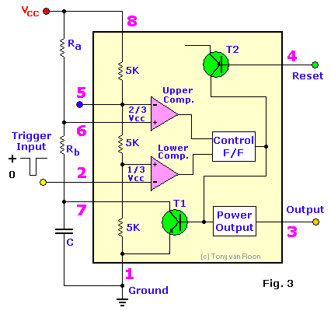**

Inside the 555 timer, there are equivalent of over 20 transistors, 15 resistors, and 2 diodes, depending of the manufacturer. The equivalent circuit, in block diagram, providing the functions of control, triggering, level sensing or comparison, discharge, and power output

Some of the more attractive features of the 555 timer are:

1) Supply voltage between 4.5 and 18 volt,

2) Supply current 3 to 6 mA

3) Rise/Fall time of 100 nSec.

The Threshold current determine the maximum value of Ra + Rb. For 15 volt operation the maximum total resistance for R (Ra +Rb) is 20 Mega-ohm.

Inside the 555 you can see three resistors, labelled R. These resistors are equal in value and form a voltage divider, providing reference voltages at 1/3 and 2/3 of the power supply voltage, VCC.

**3.3.3 OPERATION:**

The reference voltages are connected to one input of each of two comparators, which in turn control the logic state of a bistable, or flip flop stage.

Pin 2 of the 555 is the trigger input. When the voltage connected to pin 2 is less than 1/3 of the power supply voltage, the output of the lower comparator forces the logic state of the flip flop to LOW. The output stage has an inverting action. In other words, when the output of the flip flop is LOW, the output of the 555 goes HIGH

Now think about what happens when the power supply is first connected to the astable circuit. Initially, timing capacitor C is discharged. The voltage at pin 2 is 0 V and the output of the 555 is driven HIGH. C starts to charge through resistors R1 and R2. Note that C is also connected to pin 6, the threshold input of the 555.

When the voltage across C goes past 1/3 of the power supply voltage, the output of the lower comparator snaps a new level. This doesn't change the logic state of the flip flop: its output remains LOW.

The inputs to the second comparator are the voltage at pin 6, the threshold input, and 2/3 VCC from the internal voltage divider.

When the voltage across C goes past 2/3 of the power supply voltage, the output of the second comparator snaps to a new level, the flip flop changes state, its output becomes HIGH and the output of the 555 goes from HIGH to LOW.

Inside the 555, the flip flop is connected to an NPN transistor, the collector of which is connected to pin 7, the discharge pin of the 555. When the output of the flip flop goes HIGH, the transistor is switched ON, providing a low resistance path from the discharge pin to 0 V. The timing capacitor, C, starts to empty through R2 and the voltage across it decreases.

Note that the capacitor charges through R1 and R2, but discharges only through R2.

When the voltage across C decreases below 1/3 of the power supply voltage, the lower comparator snaps to a new level, the flip flop changes state and the output of the 555 goes HIGH once again.

The graph below shows how the voltage across the timing capacitor, VC , changes with the output voltage of the 555, Vout:

The initial ouptut pulse is longer than subsequent pulses because C is completely discharged when the power supply is first connected. Subsequent HIGH and low times correspond to half-charge/discharge times, either from 1/3 to 2/3 of the power supply voltage, or from 2/3 to 1/3 of the power supply voltage.

The HIGH time is given by:

HIGH time

Remember, C charges through both R1 and R2.

The LOW time is given by:

LOW time

C discharges only through R2.

The period, t, of the 555 astable is given by:

period

The frequency, f, is given by:

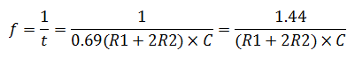

Try 1÷0.69 on your calculator to confirm that it does equal 1.44.

The design formula for the 555 astable follows from the behaviour of RC networks and from the two switching thresholds of the voltage divider inside the device.

In a 555 monostable, only the upper threshold is used to determine the period, so the formula corresponds to a 2/3 charge time:

monostable design equation

### 3.3.4 555 Timer Modes of Operation:

The 555 has three operating modes:

* [Monostable](http://en.wikipedia.org/wiki/Monostable) mode: in this mode, the 555 functions as a "one-shot" pulse generator. Applications include timers, missing pulse detection, bouncefree switches, touch switches, frequency divider, capacitance measurement, [pulse-width modulation](http://en.wikipedia.org/wiki/Pulse-width_modulation) (PWM) and so on.
* [Astable](http://en.wikipedia.org/wiki/Astable): free running mode: the 555 can operate as an [oscillator](http://en.wikipedia.org/wiki/Oscillator). Uses include [LED](http://en.wikipedia.org/wiki/Light-emitting_diode) and lamp flashers, pulse generation, logic clocks, tone generation, security alarms, [pulse position modulation](http://en.wikipedia.org/wiki/Pulse_position_modulation) and so on. Selecting a [thermistor](http://en.wikipedia.org/wiki/Thermistor) as timing resistor allows the use of the 555 in a temperature sensor: the period of the output pulse is determined by the temperature. The use of a microprocessor based circuit can then convert the pulse period to temperature, linearize it and even provide calibration means.
* [Bistable](http://en.wikipedia.org/wiki/Flip-flop_%28electronics%29) mode or [Schmitt trigger](http://en.wikipedia.org/wiki/Schmitt_trigger): the 555 can operate as a [flip-flop](http://en.wikipedia.org/wiki/Flip-flop_%28electronics%29), if the DIS pin is not connected and no capacitor is used. Uses include bounce-free latched switches.

### 1. Monostable

[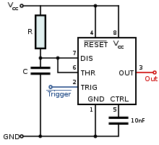](http://en.wikipedia.org/wiki/File:555_Monostable.svg)

[magnify-clip](http://en.wikipedia.org/wiki/File:555_Monostable.svg)

Schematic of a 555 in monostable mode

[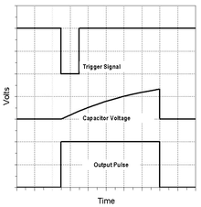](http://en.wikipedia.org/wiki/File:NE555_Monotable_Waveforms_(English).png)

[magnify-clip](http://en.wikipedia.org/wiki/File:NE555_Monotable_Waveforms_(English).png)

The relationships of the trigger signal, the voltage on C and the pulse width in monostable mode

See also: [RC circuit](http://en.wikipedia.org/wiki/RC_circuit)

In the monostable mode, the 555 timer acts as a "one-shot" pulse generator. The pulse begins when the 555 timer receives a signal at the trigger input that falls below a third of the voltage supply. The width of the output pulse is determined by the time constant of an RC network, which consists of a [capacitor](http://en.wikipedia.org/wiki/Capacitor) (C) and a [resistor](http://en.wikipedia.org/wiki/Resistor) (R). The output pulse ends when the voltage on the capacitor equals 2/3 of the supply voltage. The output pulse width can be lengthened or shortened to the need of the specific application by adjusting the values of R and C.[[5]](http://en.wikipedia.org/wiki/555_timer_IC#cite_note-4)

The output pulse width of time *t*, which is the time it takes to charge C to 2/3 of the supply voltage, is given by

t = RC\ln(3) \approx 1.1
 RC

where t is in seconds, R is in [ohms](http://en.wikipedia.org/wiki/Ohm) and C is in [farads](http://en.wikipedia.org/wiki/Farads).

While using the timer IC in monostable mode, the main disadvantage is that the time span between the two triggering pulses must be greater than the RC time constant.[[6]](http://en.wikipedia.org/wiki/555_timer_IC#cite_note-5)

### 2. Bistable

[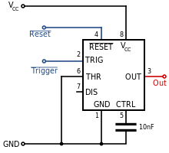](http://en.wikipedia.org/wiki/File:555_Bistable.svg)

[magnify-clip](http://en.wikipedia.org/wiki/File:555_Bistable.svg)

Schematic of a 555 in bistable mode

In bistable mode, the 555 timer acts as a basic flip-flop. The trigger and reset inputs (pins 2 and 4 respectively on a 555) are held high via [Pull-up resistors](http://en.wikipedia.org/wiki/Pull-up_resistor) while the threshold input (pin 6) is simply grounded. Thus configured, pulling the trigger momentarily to ground acts as a 'set' and transitions the output pin (pin 3) to Vcc (high state). Pulling the reset input to ground acts as a 'reset' and transitions the output pin to ground (low state). No capacitors are required in a bistable configuration. Pin 5 (control) is connected to ground via a small-value capacitor (usually 0.01 to 0.1 uF); pin 7 (discharge) is left floating.

### 3. Astable

[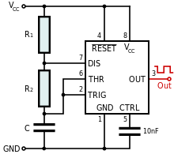](http://en.wikipedia.org/wiki/File:555_Astable_Diagram.svg)

[magnify-clip](http://en.wikipedia.org/wiki/File:555_Astable_Diagram.svg)

Standard 555 astable circuit

In astable mode, the 555 timer puts out a continuous stream of rectangular pulses having a specified frequency. Resistor R1 is connected between VCC and the discharge pin (pin 7) and another resistor (R2) is connected between the discharge pin (pin 7), and the trigger (pin 2) and threshold (pin 6) pins that share a common node. Hence the capacitor is charged through R1 and R2, and discharged only through R2, since pin 7 has low impedance to ground during output low intervals of the cycle, therefore discharging the capacitor.

In the astable mode, the frequency of the pulse stream depends on the values of R1, R2 and C:

f = \frac{1}{\ln(2) \cdot C \cdot (R_1 + 2R_2)}

The high time from each pulse is given by:

\mathrm{high} = \ln(2) \cdot (R_1 + R_2) \cdot C

and the low time from each pulse is given by:

\mathrm{low} = \ln(2) \cdot R_2 \cdot C

where R1 and R2 are the values of the resistors in [ohms](http://en.wikipedia.org/wiki/Ohm) and C is the value of the capacitor in [farads](http://en.wikipedia.org/wiki/Farad).

The power capability of R1 must be greater than \frac{V_{cc}^{2}}{R_1}.

Particularly with bipolar 555s, low values of R1 must be avoided so that the output stays saturated near zero volts during discharge, as assumed by the above equation. Otherwise the output low time will be greater than calculated above.

To achieve a [duty cycle](http://en.wikipedia.org/wiki/Duty_cycle) of less than 50% a diode can be added in parallel with R2 towards the capacitor. This bypasses R2 during the high part of the cycle so that the high interval depends only on R1 and C.

## 3.3.5 Specifications

These specifications apply to the NE555. Other 555 timers can have different specifications depending on the grade (military, medical, etc.).

|  |  |
| --- | --- |
| Supply voltage (*V*CC) | 4.5 to 15 V |
| Supply current (*V*CC = +5 V) | 3 to 6 mA |
| Supply current (*V*CC = +15 V) | 10 to 15 mA |
| Output current (maximum) | 200 mA |
| Maximum Power dissipation | 600 mW |
| Power consumption (minimum operating) | 30 mW@5V, 225 mW@15V |
| [Operating temperature](http://en.wikipedia.org/wiki/Operating_temperature) | 0 to 70 °C |

**3.3.6 APPLICATIONS:**

* Precision Timing
* Sequential Timing
* Time Delay Generation
* Pulse Generation
* Pulse Detector
* Pulse Width and Position Modulation

**DC MOTOR**

A DC motor in simple words is a device that converts direct current(electrical energy) into mechanical energy. It’s of vital importance for the industry today.

A DC motor is designed to run on DC electric power. Two examples of pure DC designs are Michael Faraday's homo-polar motor (which is uncommon), and the ball bearing motor, which is (so far) a novelty.

By far the most common DC motor types are the brushed and brushless types, which use internal and external commutation respectively to create an oscillating AC current from the DC source—so they are not purely DC machines in a strict sense.

We in our project are using brushed DC Motor, which will operate in the ratings of 12v DC 0.6A.

The speed of a DC motor can be controlled by changing the voltage applied to the armature or by changing the field current. The introduction of variable resistance in the armature circuit or field circuit allowed speed control. Modern DC motors are often controlled by power electronics  systems called DC drives.

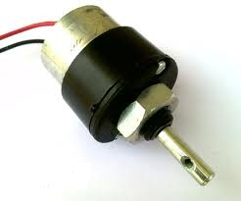

Fig. Motor

* **Usage**

The DC motor or Direct Current Motor to give it its full title, is the most commonly used actuator for producing continuous movement and whose speed of rotation can easily be controlled, making them ideal for use in applications were speed control, servo type control, and/or positioning is required. A DC motor consists of two parts, a "Stator" which is the stationary part and a "Rotor" which is the rotating part. The result is that there are basically three types of DC Motor available.

**L293D DRIVER CIRCUIT**

L293D IC generally comes as a standard 16-pin DIP (dual-in line package). This motor driver IC can simultaneously control two small motors in either direction; forward and reverse with just 4 microcontroller pins (if you do not use enable pins).

**Some of the features (and drawbacks) of this IC are:**

1. Output current capability is limited to 600mA per channel with peak output current limited to 1.2A (non-repetitive). This means you cannot drive bigger motors with this IC. However, most small motors used in hobby robotics should work. If you are unsure whether the IC can handle a particular motor, connect the IC to its circuit and run the motor with your finger on the IC. If it gets really hot, then beware... Also note the words "non-repetitive"; if the current output repeatedly reaches 1.2A, it might destroy the drive transistors.
2. Supply voltage can be as large as 36 Volts. This means you do not have to worry much about voltage regulation.
3. L293D has an enable facility which helps you enable the IC output pins. If an enable pin is set to logic high, then state of the inputs match the state of the outputs. If you pull this low, then the outputs will be turned off regardless of the input states
4. The datasheet also mentions an "over temperature protection" built into the IC. This means an internal sensor senses its internal temperature and stops driving the motors if the temperature crosses a set point
5. Another major feature of **L293D** is its internal clamp diodes. This flyback diode helps protect the driver IC from voltage spikes that occur when the motor coil is turned on and off (mostly when turned off)
6. The logical low in the IC is set to 1.5V. This means the pin is set high only if the voltage across the pin crosses 1.5V which makes it suitable for use in high frequency applications like switching applications (upto 5KHz)
7. Lastly, this integrated circuit not only drives DC motors, but can also be used to drive relay solenoids, stepper motors etc.

**Description**

It works on the concept of H-bridge. H-bridge is a circuit which allows the voltage to be flown in either direction. As you know voltage need to change its direction for being able to rotate the motor in clockwise or anticlockwise direction, Hence H-bridge IC are ideal for driving a DC motor.

In a single l293d chip there two h-Bridge circuit inside the IC which can rotate two dc motor independently. Due its size it is very much used in robotic application for controlling DC motors. Given below is the pin diagram of a L293D motor controller.

There are two Enable pins on l293d. Pin 1 and pin 9, for being able to drive the motor, the pin 1 and 9 need to be high. For driving the motor with left H-bridge you need to enable pin 1 to high. And for right H-Bridge you need to make the pin 9 to high. If anyone of the either pin1 or pin9 goes low then the motor in the corresponding section will suspend working. It’s like a switch.

**Pin Diagram**

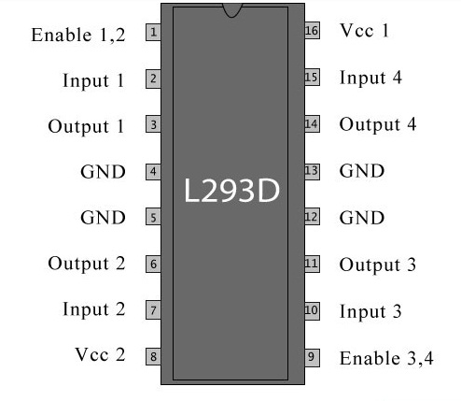

Fig showing pin diagram of L293D

**Pin Description**

|  |  |  |
| --- | --- | --- |
| **Pin No** | **Function** | **Name** |
| 1 | Enable pin for Motor 1; active high | Enable 1,2 |
| 2 | Input 1 for Motor 1 | Input 1 |
| 3 | Output 1 for Motor 1 | Output 1 |
| 4 | Ground (0V) | Ground |
| 5 | Ground (0V) | Ground |
| 6 | Output 2 for Motor 1 | Output 2 |
| 7 | Input 2 for Motor 1 | Input 2 |
| 8 | Supply voltage for Motors; 9-12V (up to 36V) | Vcc 2 |
| 9 | Enable pin for Motor 2; active high | Enable 3,4 |
| 10 | Input 1 for Motor 1 | Input 3 |
| 11 | Output 1 for Motor 1 | Output 3 |
| 12 | Ground (0V) | Ground |
| 13 | Ground (0V) | Ground |
| 14 | Output 2 for Motor 1 | Output 4 |
| 15 | Input2 for Motor 1 | Input 4 |
| 16 | Supply voltage; 5V (up to 36V) | Vcc 1 |

**Table Pin Description of L293D**

**Working of L293D**

The 4 input pins for this l293d, pin 2,7 on the left and pin 15 ,10 on the right as shown on the pin diagram. Left input pins will regulate the rotation of motor connected across left side and right input for motor on the right hand side. The motors are rotated on the basis of the inputs provided across the input pins as LOGIC 0 or LOGIC 1.

In simple you need to provide Logic 0 or 1 across the input pins for rotating the motor.

**Voltage Specification**

VCC is the voltage that it needs for its own internal operation 5v; l293D will not use this voltage for driving the motor. For driving the motor it has a separate provision to provide motor supply VSS (V supply).  L293d will use this to drive the motor. It means if you want to operate a motor at 9V then you need to provide a Supply of 9V across VSS Motor supply.

The maximum voltage for VSS motor supply is 36V. It can supply a max current of 600mA per channel. Since it can drive motors Up to 36v hence you can drive pretty big motors with this l293d.

VCC pin 16 is the voltage for its own internal Operation. The maximum voltage ranges from 5v and up to 36v. **HT9170B**

**DTMF RECIEVER**

The HT9170B/D are Dual Tone Multi Frequency (DTMF) receivers integrated with digital decoder and band split filter functions as well as power-down mode and inhibit mode operations. Such devices use digital counting techniques to detect and decode all the 16 DTMF tone pairs into a 4-bit code output.

Highly accurate switched capacitor filters are implemented to divide tone signals into low and high group signals. A built-in dial tone rejection circuit is provided to eliminate the need for pre-filtering.

The DTMF (Dual Tone Multiple Frequency) application is associated with digital telephony, and provides two selected output frequencies (one high band, one low band) for a duration of 100 ms. A benchmark subroutine has been written for the COP820C/840C microcontrollers, and is outlined in detail in this application note. This DTMF subroutine takes 110 bytes of COP820C/840C code, consisting of 78 bytes

of program code and 32 bytes of ROM table. The timings in this DTMF subroutine are based on a 20 MHz

COP820C/840C clock, giving an instruction cycle time of 1 ms.The matrix for selecting the high and low band frequencies associated with each key is shown in Figure 1 . Each key is uniquely referenced by selecting one of the four low band frequencies associated with the matrix rows, coupled with selecting one of the four high band frequencies associated with the matrix columns. The low band frequencies are 697,

770, 852, and 941 Hz, while the high band frequencies are 1209, 1336, 1477, and 1633 Hz. The DTMF subroutine assumes that the key decoding is supplied as a low order hex digit in the accumulator. The COP820C/840C DTMF subroutine will then generate the selected high band and low

band frequencies on port G output pins G3 and G2 respectively for a duration of 100 ms. The COP820C/840C each contain only one timer. The problem is that three different times must be generated to satisfy the DTMF application. These three times are the periods of the two selected frequencies and the 100 ms duration period. Obviously the single timer can be used to generate any one (or possibly two) of the required times, with the program having to generate the other two (or one) times. The solution to the DTMF problem lies in dividing the 100 ms time duration by the half periods (rounded to the nearest

micro second) for each of the eight frequencies, and then examining the respective high band and low band quotients and remainders. The results of these divisions are detailed in Table I. The low band frequency quotients range from 139 to 188, while the high band quotients range from 241 to 326.

The observation that only the low band quotients will each fit in a single byte dictates that the high band frequency be produced by the 16 bit (2 byte) COP820C/840C timer running in PWM (Pulse Width Modulation) Mode. TL/

**2.8.1 FEAUTURES:**

* Operating voltage: 2.5V~5.5V
* Minimal external components
* No external filter is required
* Low standby current (on power down mode)
* Excellent performance
* Tristate data output for MCU interface
* 3.58MHz crystal or ceramic resonator
* 1633Hz can be inhibited by the INH pin
* HT9170B: 18-pin DIP package



**BLOCK DIAGRAM:**

****

**FUNCTIONAL DESCRIPTION:**

The HT9170B/D tone decoders consist of three band pass filters and two digital decode circuits to convert a tone (DTMF) signal into digital code output.

An operational amplifier is built-in to adjust the input signal. The pre-filter is a band rejection filter, which reduces the dialing tone from 350Hz to 400Hz.

The low group filter filters low group frequency signal output whereas the high group filter filters high group Frequency signal output. A zero-crossing detector with follows each filters output hysteretic. When each signal amplitude at the output exceeds the specified level, it is transferred to full swing logic signal.

When input signals are recognized to be effective, DV becomes high, and the correct tone code (DTMF) digit is transferred.



#### Steering control circuit:

The steering control circuit is used for measuring the effective signal duration and for protecting against drop out of valid signals. It employs the analog delay by external RC time-constant controlled by EST.

The EST pin is normally low and draws the RT/GT pin to keep low through discharge of external RC. When a valid tone input is detected, EST goes high to charge RT/GT through RC.

When the voltage of RT/GT changes from 0 to VTRT (2.35V for 5V supply), the input signal is effective, and the code detector will create the correct code. After D0~D3 are completely latched, DV output becomes high. When the voltage of RT/GT falls down from VDD to VTRT (i.e. when there is no input tone), DV output becomes Low, and D0~D3 keeps data until a next valid tone input is produced. By selecting adequate external RC value, the minimum acceptable input tone duration (tACC) and the minimum acceptable inter-tone rejection (tIR) can be set. External

Components (R, C) are chosen by the formula.

**TIMING DIAGRAM**

**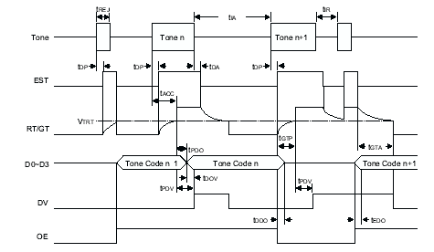**

### 2.8.4 Applications

* PABX
* Central office
* Mobile radio
* Remote control
* Remote data entry
  + Call limiting

**LIQUID CRYSTAL DISPLAY(LCD)**

LCD (Liquid Crystal Display) screen is an electronic display module and find a wide range of applications. A 16x2 LCD display is very basic module and is very commonly used in various devices and circuits. These modules are preferred over [seven segments](http://www.engineersgarage.com/content/seven-segment-display) and other multi segment [LED](http://www.engineersgarage.com/content/led)s. The reasons being: LCDs are economical; easily programmable; have no limitation of displaying special & even [custom characters](http://www.engineersgarage.com/microcontroller/8051projects/create-custom-characters-LCD-AT89C51) (unlike in seven segments), [animations](http://www.engineersgarage.com/microcontroller/8051projects/display-custom-animations-LCD-AT89C51) and so on.

A **16x2 LCD** means it can display 16 characters per line and there are 2 such lines. In this LCD each character is displayed in 5x7 pixel matrix. This LCD has two registers, namely, Command and Data.

The command register stores the command instructions given to the LCD. A command is an instruction given to LCD to do a predefined task like initializing it, clearing its screen, setting the cursor position, controlling display etc. The data register stores the data to be displayed on the LCD. The data is the ASCII value of the character to be displayed on the LCD.

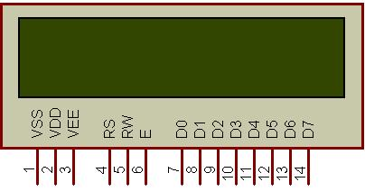

Fig. 16x2 LCD

**Introduction**

The most commonly used Character based LCDs are based on Hitachi's HD44780 controller or other which are compatible with HD44580.

**Pin Description**

Most LCDs with 1 controller has 14 Pins and LCDs with 2 controller has 16 Pins (two pins are extra in both for back-light LED connections). Pin description is shown in the table below.

**Pin Configuration table for a 16X2 LCD character display:-**

|  |  |  |
| --- | --- | --- |
| **Pin Number** | **Symbol** | **Function** |
| **1** | Vss | Ground Terminal |
| **2** | Vcc | Positive Supply |
| **3** | Vdd | Contrast adjustment |
| **4** | RS | Register Select; 0→Instruction Register, 1→Data Register |
| **5** | R/W | Read/write Signal; 1→Read, 0→ Write |
| **6** | E | Enable; Falling edge |
| **7** | DB0 | Bi-directional data bus, data transfer is performed once, thru DB0 to DB7, in the case of interface data length is 8-bits; and twice, through DB4 to DB7 in the case of interface data length is 4-bits. Upper four bits first then lower four bits. |
| **8** | DB1 |
| **9** | DB2 |
| **10** | DB3 |
| **11** | DB4 |
| **12** | DB5 |
| **13** | DB6 |
| **14** | DB7 |
| **15** | LED-(K) | Back light LED cathode terminal |
| **16** | LED+(A) | Back Light LED anode terminal |

Table Pin Description Of LCD

**Data/Signals/Execution of LCD**

Coming to data, signals and execution.

LCD accepts two types of signals, one is data, and another is control. These signals are recognized by the LCD module from status of the RS pin. Now data can be read also from the LCD display, by pulling the R/W pin high. As soon as the E pin is pulsed, LCD display reads data at the falling edge of the pulse and executes it, same for the case of transmission.

                LCD display takes a time of 39-43µS to place a character or execute a command. Except for clearing display and to seek cursor to home position it takes 1.53ms to 1.64ms. Any attempt to send any data before this interval may lead to failure to read data or execution of the current data in some devices. Some devices compensate the speed by storing the incoming data to some temporary registers.

**Instruction Register (IR) and Data Register (DR)**

There are two 8-bit registers in HD44780 controller Instruction and Data register. Instruction register corresponds to the register where you send commands to LCD e.g LCD shift command, LCD clear, LCD address etc. and Data register is used for storing data which is to be displayed on LCD. when send the enable signal of the LCD is asserted, the data on the pins is latched in to the data register and data is then moved automatically to the DDRAM and hence is displayed on the LCD. Data Register is not only used for sending data to DDRAM but also for CGRAM, the address where you want to send the data, is decided by the instruction you send to LCD. We will discuss more on LCD instruction set further in this tutorial.

**Commands and Instruction set**

Only the instruction register (IR) and the data register (DR) of the LCD can be controlled by the MCU. Before starting the internal operation of the LCD, control information is temporarily stored into these registers to allow interfacing with various MCUs, which operate at different speeds, or various peripheral control devices. The internal operation of the LCD is determined by signals sent from the MCU. These signals, which include register selection signal (RS), read/write signal (R/W), and the data bus (DB0 to DB7), make up the LCD instructions (Table 3). There are four categories of instructions that:

* Designate LCD functions, such as display format, data length, etc.
* Set internal RAM addresses
* Perform data transfer with internal RAM
* Perform miscellaneous functions

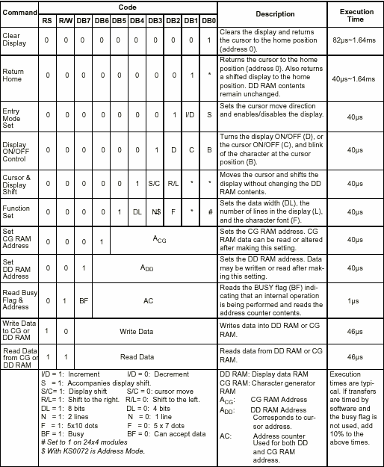

Table Showing various LCD Command Description

Although looking at the table you can make your own commands and test them. Below is a brief list of useful commands which are used frequently while working on the LCD.

**List Of Command**

|  |  |  |  |
| --- | --- | --- | --- |
| **No.** | **Instruction** | **Hex** | **Decimal** |
| 1 | Function Set: 8-bit, 1 Line, 5x7 Dots | 0x30 | 48 |
| 2 | Function Set: 8-bit, 2 Line, 5x7 Dots | 0x38 | 56 |
| 3 | Function Set: 4-bit, 1 Line, 5x7 Dots | 0x20 | 32 |
| 4 | Function Set: 4-bit, 2 Line, 5x7 Dots | 0x28 | 40 |
| 5 | Entry Mode | 0x06 | 6 |
| 6 | Display off Cursor off (clearing display without clearing DDRAM content) | 0x08 | 8 |
| 7 | Display on Cursor on | 0x0E | 14 |
| 8 | Display on Cursor off | 0x0C | 12 |
| 9 | Display on Cursor blinking | 0x0F | 15 |
| 10 | Shift entire display left | 0x18 | 24 |
| 12 | Shift entire display right | 0x1C | 30 |
| 13 | Move cursor left by one character | 0x10 | 16 |
| 14 | Move cursor right by one character | 0x14 | 20 |
| 15 | Clear Display (also clear DDRAM content) | 0x01 | 1 |
| 16 | Set DDRAM address or coursor position on display | 0x80+add\* | 128+add\* |
| 17 | Set CGRAM address or set pointer to CGRAM location | 0x40+add\*\* | 64+add\*\* |

Table : Frequently Used Commands And Instructions For Lcd

\* DDRAM address given in LCD basics section see Figure 2,3,4  
\*\* CGRAM address from 0x00 to 0x3F, 0x00 to 0x07 for char1 and so on.

**Liquid crystal displays interfacing with Controller**

The LCD standard requires 3 control lines and 8 I/O lines for the data bus.

• **8 data pins D7:D0**

Bi-directional data/command pins.  
Alphanumeric characters are sent in ASCII format.

• **RS:  Register Select**

RS = 0 -> Command Register is selected  
RS = 1 -> Data Register is selected

• **R/W: Read or Write**

0 -> Write,  1 -> Read

• **E: Enable (Latch data)**

Used to latch the data present on the data pins.  
A high-to-low edge is needed to latch the data.

**RELAY:**

A **relay** is an electrically operated switch. Many relays use an electromagnet to operate a switching mechanism, but other operating principles are also used. Relays find applications where it is necessary to control a circuit by a low-power signal, or where several circuits must be controlled by one signal. The first relays were used in long distance telegraph circuits, repeating the signal coming in from one circuit and re-transmitting it to another. Relays found extensive use in telephone exchanges and early computers to perform logical operations. A type of relay that can handle the high power required to directly drive an electric motor is called a contactor. Solid-state relays control power circuits with no moving parts, instead using a semiconductor device triggered by light to perform switching. Relays with calibrated operating characteristics and sometimes multiple operating coils are used to protect electrical circuits from overload or faults; in modern electric power systems these functions are performed by digital instruments still called "protection relays".

**Basic design and operation:**

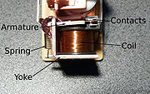

Simple electromechanical relay

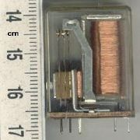

Small relay as used in electronics

A simple electromagnetic relay, such as the one taken from a car in the first picture, is an adaptation of an electromagnet. It consists of a coil of wire surrounding a soft iron core, an iron yoke, which provides a low reluctance path for magnetic flux, a movable iron [armature](http://en.wikipedia.org/wiki/Armature_%28electrical_engineering%29), and a set, or sets, of contacts; two in the relay pictured. The armature is hinged to the yoke and mechanically linked to a moving contact or contacts. It is held in place by a spring so that when the relay is de-energized there is an air gap in the magnetic circuit. In this condition, one of the two sets of contacts in the relay pictured is closed, and the other set is open. Other relays may have more or fewer sets of contacts depending on their function. The relay in the picture also has a wire connecting the armature to the yoke. This ensures continuity of the circuit between the moving contacts on the armature, and the circuit track on the printed circuit board (PCB) via the yoke, which is soldered to the PCB.

When an electric current is passed through the coil, the resulting magnetic field attracts the armature and the consequent movement of the movable contact or contacts either makes or breaks a connection with a fixed contact. If the set of contacts was closed when the relay was De-energized, then the movement opens the contacts and breaks the connection, and vice versa if the contacts were open. When the current to the coil is switched off, the armature is returned by a force, approximately half as strong as the magnetic force, to its relaxed position. Usually this force is provided by a spring, but gravity is also used commonly in industrial motor starters. Most relays are manufactured to operate quickly. In a low voltage application, this is to reduce noise. In a high voltage or high current application, this is to reduce arcing.

If the coil is energized with DC, a diode is frequently installed across the coil, to dissipate the energy from the collapsing magnetic field at deactivation, which would otherwise generate a voltage spike dangerous to circuit components. Some automotive relays already include a diode inside the relay case. Alternatively a contact protection network, consisting of a capacitor and resistor in series, may absorb the surge. If the coil is designed to be energized with AC, a small copper ring can be crimped to the end of the solenoid. This "shading ring" creates a small out-of-phase current, which increases the minimum pull on the armature during the AC cycle.

By analogy with the functions of the original electromagnetic device, a solid-state relay is made with a thyristor or other solid-state switching device. To achieve electrical isolation an opt coupler can be used which is a light-emitting diode (LED) coupled with a photo transistor.

## Types

### Latching relay

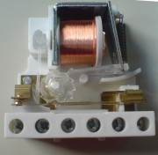

Latching relay, dust cover removed, showing pawl and ratchet mechanism. The ratchet operates a cam, which raises and lowers the moving contact arm, seen edge-on just below it. The moving and fixed contacts are visible at the left side of the image.

A **latching relay** has two relaxed states (bistable). These are also called "impulse", "keep", or "stay" relays. When the current is switched off, the relay remains in its last state. This is achieved with a solenoid operating a ratchet and cam mechanism, or by having two opposing coils with an over-center spring or permanent magnet to hold the armature and contacts in position while the coil is relaxed, or with a remanent core. In the ratchet and cam example, the first pulse to the coil turns the relay on and the second pulse turns it off. In the two coil example, a pulse to one coil turns the relay on and a pulse to the opposite coil turns the relay off. This type of relay has the advantage that it consumes power only for an instant, while it is being switched, and it retains its last setting across a power outage. A remanent core latching relay requires a current pulse of opposite polarity to make it change state.

### Reed relay

A **reed relay** has a set of contacts inside a vacuum or inert gas filled glass tube, which protects the contacts against atmospheric corrosion. The contacts are closed by a magnetic field generated when current passes through a coil around the glass tube. Reed relays are capable of faster switching speeds than larger types of relays, but have low switch current and voltage ratings.

[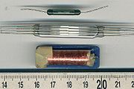](http://en.wikipedia.org/wiki/File:Reedrelay.jpg)

### Mercury-wetted relay

A **mercury-wetted reed relay** is a form of reed relay in which the contacts are wetted with mercury. Such relays are used to switch low-voltage signals (one volt or less) because of their low contact resistance, or for high-speed counting and timing applications where the mercury eliminates contact bounce. Mercury wetted relays are position-sensitive and must be mounted vertically to work properly. Because of the toxicity and expense of liquid mercury, these relays are rarely specified for new equipment. See also mercury switch.

### Polarized relay

A **polarized relay** placed the armature between the poles of a permanent magnet to increase sensitivity. Polarized relays were used in middle 20th Century telephone exchanges to detect faint pulses and correct telegraphic distortion. The poles were on screws, so a technician could first adjust them for maximum sensitivity and then apply a bias spring to set the critical current that would operate the relay.

### Machine tool relay

A **machine tool relay** is a type standardized for industrial control of machine tools, transfer machines, and other sequential control. They are characterized by a large number of contacts (sometimes extendable in the field) which are easily converted from normally-open to normally-closed status, easily replaceable coils, and a form factor that allows compactly installing many relays in a control panel. Although such relays once were the backbone of automation in such industries as automobile assembly, the programmable logic controller (PLC) mostly displaced the machine tool relay from sequential control applications.

### Contactor relay

A **contactor** is a very heavy-duty relay used for switching electric motors and lighting loads. Continuous current ratings for common contactors range from 10 amps to several hundred amps. High-current contacts are made with alloys containing silver. The unavoidable arcing causes the contacts to oxidize; however, silver oxide is still a good conductor. Such devices are often used for motor starters. A motor starter is a contactor with overload protection devices attached. The overload sensing devices are a form of heat operated relay where a coil heats a bi-metal strip, or where a solder pot melts, releasing a spring to operate auxiliary contacts. These auxiliary contacts are in series with the coil. If the overload senses excess current in the load, the coil is de-energized. Contactor relays can be extremely loud to operate, making them unfit for use where noise is a chief concern.

### Solid-state relay

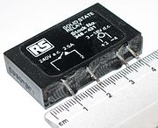

[http://bits.wikimedia.org/skins-1.5/common/images/magnify-clip.png](http://en.wikipedia.org/wiki/File:Solid_state_relay.jpg)

Solid state relay, which has no moving parts

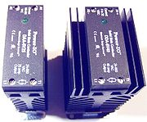

25 A or 40 A solid state contactors

A **solid state relay** (**SSR**) is a solid state electronic component that provides a similar function to an electromechanical relay but does not have any moving components, increasing long-term reliability. With early SSR's, the tradeoff came from the fact that every transistor has a small voltage drop across it. This voltage drop limited the amount of current a given SSR could handle. As transistors improved, higher current SSR's, able to handle 100 to 1,200 Amperes, have become commercially available. Compared to electromagnetic relays, they may be falsely triggered by transients.

### Solid state contactor relay

A **solid state contactor** is a very heavy-duty solid state relay, including the necessary heat sink, used for switching electric heaters, small electric motors and lighting loads; where frequent on/off cycles are required. There are no moving parts to wear out and there is no contact bounce due to vibration. They are activated by AC control signals or DC control signals from Programmable logic controller (PLCs), PCs, Transistor-transistor logic (TTL) sources, or other microprocessor and microcontroller controls.

### Buchholz relay

A **Buchholz relay** is a safety device sensing the accumulation of gas in large oil-filled transformers, which will alarm on slow accumulation of gas or shut down the transformer if gas is produced rapidly in the transformer oil.

### Forced-guided contacts relay

A **forced-guided contacts relay** has relay contacts that are mechanically linked together, so that when the relay coil is energized or de-energized, all of the linked contacts move together. If one set of contacts in the relay becomes immobilized, no other contact of the same relay will be able to move. The function of forced-guided contacts is to enable the safety circuit to check the status of the relay. Forced-guided contacts are also known as "positive-guided contacts", "captive contacts", "locked contacts", or "safety relays".

### Overload protection relay

Electric motors need over current protection to prevent damage from over-loading the motor, or to protect against short circuits in connecting cables or internal faults in the motor windings. One type of electric motor overload protection relay is operated by a heating element in series with the electric motor. The heat generated by the motor current heats a bimetallic strip or melts solder, releasing a spring to operate contacts. Where the overload relay is exposed to the same environment as the motor, a useful though crude compensation for motor ambient temperature is provided.

## Pole and throw:

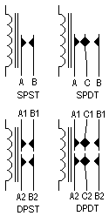

Circuit symbols of relays. *"C" denotes the common terminal in SPDT and DPDT types.*

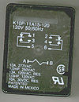

The diagram on the package of a DPDT AC coil relay

Since relays are switches, the terminology applied to switches is also applied to relays. A relay will switch one or more *poles*, each of whose contacts can be *thrown* by energizing the coil in one of three ways:

* Normally-open (**NO**) contacts connect the circuit when the relay is activated; the circuit is disconnected when the relay is inactive. It is also called a **Form A** contact or "make" contact.
* Normally-closed (**NC**) contacts disconnect the circuit when the relay is activated; the circuit is connected when the relay is inactive. It is also called a **Form B** contact or "break" contact.
* Change-over (**CO**), or double-throw (**DT**), contacts control two circuits: one normally-open contact and one normally-closed contact with a common terminal. It is also called a **Form C** contact or "transfer" contact ("break before make"). If this type of contact utilizes”make before break" functionality, then it is called a **Form D** contact.

The following designations are commonly encountered:

* **SPST** – Single Pole Single Throw. These have two terminals which can be connected or disconnected. Including two for the coil, such a relay has four terminals in total. It is ambiguous whether the pole is normally open or normally closed. The terminology "SPNO" and "SPNC" is sometimes used to resolve the ambiguity.
* **SPDT** – Single Pole Double Throw. A common terminal connects to either of two others. Including two for the coil, such a relay has five terminals in total.
* **DPST** – Double Pole Single Throw. These have two pairs of terminals. Equivalent to two SPST switches or relays actuated by a single coil. Including two for the coil, such a relay has six terminals in total. The poles may be Form A or Form B (or one of each).
* **DPDT** – Double Pole Double Throw. These have two rows of change-over terminals. Equivalent to two SPDT switches or relays actuated by a single coil. Such a relay has eight terminals, including the coil.

The "S" or "D" may be replaced with a number, indicating multiple switches connected to a single actuator. For example 4PDT indicates a four pole double throw relay (with 14 terminals).

## Applications:

Relays are used to and for:

* Control a high-voltage circuit with a low-voltage signal, as in some types of modems or audio amplifiers,
* Control a high-current circuit with a low-current signal, as in the starter solenoid of an automobile,
* Detect and isolate faults on transmission and distribution lines by opening and closing circuit breakers (protection relays),

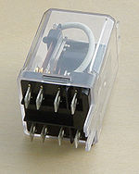

A DPDT AC coil relay with "ice cube" packaging

* Isolate the controlling circuit from the controlled circuit when the two are at different potentials, for example when controlling a mains-powered device from a low-voltage switch. The latter is often applied to control office lighting as the low voltage wires are easily installed in partitions, which may be often moved as needs change. They may also be controlled by room occupancy detectors in an effort to conserve energy,
* Logic functions. For example, the boolean AND function is realised by connecting normally open relay contacts in series, the OR function by connecting normally open contacts in parallel. The change-over or Form C contacts perform the XOR (exclusive or) function. Similar functions for NAND and NOR are accomplished using normally closed contacts. The Ladder programming language is often used for designing relay logic networks.
  + Early computing. Before vacuum tubes and transistors, relays were used as logical elements in digital computers. See ARRA (computer), Harvard Mark II, Zuse Z2, and Zuse Z3.
  + Safety-critical logic. Because relays are much more resistant than semiconductors to nuclear radiation, they are widely used in safety-critical logic, such as the control panels of radioactive waste-handling machinery.
* Time delay functions. Relays can be modified to delay opening or delay closing a set of contacts. A very short (a fraction of a second) delay would use a copper disk between the armature and moving blade assembly. Current flowing in the disk maintains magnetic field for a short time, lengthening release time. For a slightly longer (up to a minute) delay, a dashpot is used. A dashpot is a piston filled with fluid that is allowed to escape slowly. The time period can be varied by increasing or decreasing the flow rate. For longer time periods, a mechanical clockwork timer is installed.

## Relay application considerations:

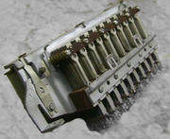

A large relay with two coils and many sets of contacts, used in an old telephone switching system.

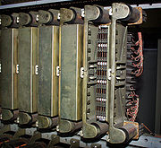

Several 30-contact relays in "Connector" circuits in mid 20th century 1XB switch and 5XB switch telephone exchanges; cover removed on one

Selection of an appropriate relay for a particular application requires evaluation of many different factors:

* Number and type of contacts – normally open, normally closed, (double-throw)
* Contact sequence – "Make before Break" or "Break before Make". For example, the old style telephone exchanges required Make-before-break so that the connection didn't get dropped while dialing the number.
* Rating of contacts – small relays switch a few amperes, large contactors are rated for up to 3000 amperes, alternating or direct current
* Voltage rating of contacts – typical control relays rated 300 VAC or 600 VAC, automotive types to 50 VDC, special high-voltage relays to about 15 000 V
* Coil voltage – machine-tool relays usually 24 VAC, 120 or 250 VAC, relays for switchgear may have 125 V or 250 VDC coils, "sensitive" relays operate on a few mill amperes
* Coil current
* Package/enclosure – open, touch-safe, double-voltage for isolation between circuits, explosion proof, outdoor, oil and splash resistant, washable for printed circuit board assembly
* Assembly – Some relays feature a sticker that keeps the enclosure sealed to allow PCB post soldering cleaning, which is removed once assembly is complete.
* Mounting – sockets, plug board, rail mount, panel mount, through-panel mount, enclosure for mounting on walls or equipment
* Switching time – where high speed is required
* "Dry" contacts – when switching very low level signals, special contact materials may be needed such as gold-plated contacts
* Contact protection – suppress arcing in very inductive circuits
* Coil protection – suppress the surge voltage produced when switching the coil current
* Isolation between coil circuit and contacts
* Aerospace or radiation-resistant testing, special quality assurance
* Expected mechanical loads due to acceleration – some relays used in aerospace applications are designed to function in shock loads of 50 *g* or more
* Accessories such as timers, auxiliary contacts, pilot lamps, test buttons
* Regulatory approvals
* Stray magnetic linkage between coils of adjacent relays on a printed circuit board.

**Advantages of relays:**

* Relays can switch **AC and DC**, transistors can only switch DC.
* Relays can switch **high voltages**, transistors cannot.
* Relays are a better choice for switching **large currents** (> 5A).
* Relays can switch **many contacts** at once.

**Disadvantages of relays:**

* Relays are **bulkier** than transistors for switching small currents.
* Relays **cannot switch rapidly** (except reed relays), transistors can switch many times per second.
* Relays **use more power** due to the current flowing through their coil.
* Relays **require more current than many ICs can provide**, so a low power transistor may be needed to switch the current for the relay's coil.

**CHAPTER 5**

**CIRCUIT DIAGRAM**

**WORKING PROCESS:**

In our project we make use of 555 Timer, Relayand DTMF Decoder which are dedicated at the water pump. The microcontroller forms the heart of the. Also a mobile phone which will operates the irrigation motor based on the DTMF technology.

Here we are going to operate the motor. For this we will use DTMF (Dual Tone Multiple Frequency) technology. To operate the motor initially we should make a call to the mobile phone which one at the motor end. That mobile phone will be automatically will be answered after one or two rings then the control of the motor is in our hands by using keypad buttons of our mobile phone the motor will be ON/OFF.

The design of this system is very much sensitive and should be handled with utmost care because the microcontroller is a 5 volts device and it is employed to monitor the house hold power consumption per day where it should be interfaced with a 240 volts energy meter. So every small parameter should be given high importance while designing the interfacing circuit between the controller and the water motor.

**ADVANTAGES:**

1. Controls high voltage water pumps.
2. Feedback generated with the help of LED indicator.
3. Highly sensitive.
4. Power saving.
5. Low cost.
6. Remote control from any where in the world.

**APPLICATIONS:**

1. Utilized for irrigation purpose.
2. Very useful for illiterates operation.
3. Can be operated from any place in the world.

User friendly.

**CONCLUSION**

* We have develop a project “DTMF controlled Irrigation motor /AC appliances” In this project we make the use of Dual Tone Multiple Frequency (DTMF) technology by using this can control the farm irrigation motor pump and other irrigation system from your place. This system is very low cast so that normal person can buy and use

**REFERENCES**

The sites which were used while doing this project:

1. [www.wikipedia.com](http://www.wikipedia.com)

2. [www.allaboutcircuits.com](http://www.allaboutcircuits.com)

3. [www.microchip.com](http://www.microchip.com)

4. [www.howstuffworks.com](http://www.howstuffworks.com)

**Books referred:**

1. Raj kamal –Microcontrollers Architecture, Programming, Interfacing and System Design.
2. Mazidi and Mazidi –Embedded Systems.
3. ARDUINO Microcontroller Manual – Microchip.
4. Embedded C –Michael.J.Pont.